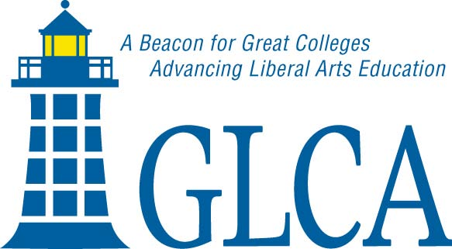
Travel Projects
Report Form

Endowment for the Study of Japan
Great Lakes Colleges Association
535 W. William, Suite 301
Ann Arbor, MI 48103
734-661-2350
Fax: 734-661-2349
www.glca.org

Name:
Campus:
Project Title:
Dates of Travel:

This report should include a one to two page summary evaluation of the project, noting which project objectives were met, which were not, benefits to the home campus and, where appropriate, collaboration with consortial campuses, and whether this project might lead to further research opportunities, professional collaborations, new courses or revised course designs. We would like to have copies of any resulting publications or digital media and if you have some digital photos you would be willing to share, please send them to us as well.

Please submit your report to Simon Gray (gray@glca.org).

