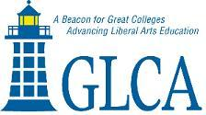

GLCA NEW WRITERS AWARD
Author’s Statement of Agreement and Certification

As a recipient of the Great Lakes Colleges Association New Writers Award, I agree to participate in the New Writers series of visits to individual colleges by invitation. I understand that these campus visits are an integral part of the award, and that my acceptance of the award signifies my willingness to travel to no more than thirteen GLCA sites, where I will meet with students, offer readings of my work, and participate in discussions, lectures, colloquia, readings, workshops, seminars, and interviews as appropriate.

Each campus or off-campus site will provide me with an honorarium and cover all travel, food and lodging expenses, as stipulated in the official rules of the competition.

I also certify that the submitted work is my first published volume in the genre.

_________________________________________ _________________________
Signature Date

_______________________________________
Please print name

